Email with Webmail

Overview

Contents
Messaging 2
Quick Pitch 2
Top-line Benefits 2
Detailed Benefits 2
Features 4
Features Overview 4
Customer Experience 6
Sales Support 12
Probing Questions 12
Selling Points 13
Objection Handlers 14
Frequently Asked Questions 16
General 16
Full Feature List: Webmail 19

Messaging

Quick Pitch
Your business relies on secure and reliable email communications to communicate with prospects, customers and staff.
You need branded, domain-based email that promotes your business every time emails are exchanged and not your service provider or any other company. You need simple to use email that works on any device and provides the necessary tools your employees need to improve productivity.
With our email packages, you can create and manage accounts, and get anywhere access to your email through Webmail.
Webmail can help simplify your day-to-day to-do list with intuitive productivity tools built into your Inbox: manage your time with TaskBox and easily find and access files anywhere with Online Storage.
Manage all of your personal and business email accounts in one Inbox. Get more time back in your day.

Top-line Benefits
- Look professional. Customers trust businesses with domain-based email over free or other email service providers. Make sure your brand is front and center in all of your collateral and communications.
- Be more productive. By creating one central place for your different email accounts, tasks and your calendar, getting business done is effective and productive like never before.
- Stay organized. Turn your emails into tasks while also being able to categorize emails, keep a list of tasks, set due dates and reminders and even assign a task to someone else if needed!
- Online Storage. Access emails, documents, or attachments from everywhere.*
- Enhanced calendar. See free/busy views of colleagues; and share your availability publically with a calendar link. Plus share/subscribe to calendars, and improved features included map links and more.*

*Enhanced and Premium features.

Detailed Benefits
Basic Features
Easy to Use | - Set up email accounts in seconds with MailManager or EasyMail Setup.  - Free, easy-to-use Webmail interface to manage your email.  - Visual cues such as tagging emails with color-code helps organize messages and email threads.
Stay Organized with TaskBox | - Turn your emails into tasks and flag them with different status flags such as to-do, priority, pending, future and more.  - Set reminders and add due dates to emails in order to help you stay organized.
Ad Free | - Avoid invasive ads, creating a cleaner, secure and distraction-free experience for you and your employees.
Secure and Reliable | - Our email is securely hosted and monitored 24/7 so you can rest assured your business is in good hands.

Added Enhanced and Premium Features

Stay Organized with TaskBox | - Add collaborators to tasks, with email notifications.*
Anytime File Access with Online Storage* | - Access attachments, documents and other files anywhere with Online Storage.  - Easy one-click uploading of attachments.
Multi-Inbox Support | - Connect and manage external email accounts (Gmail, Yahoo, etc.) through your Webmail Inbox.
Scheduling Made Easy | - Save time and effort by using the Smart “Time Finder” time slot generator to take the guess work out of planning a meeting.  - Easily see your contacts availability by sharing your calendar with your fellow employees.
Attachment View | - View and download received attachments in one list—and sort by date, sender, file type and more.

Features

Features Overview
Email Setup | - Create and manage new and existing domain-based email accounts or alias email addresses in two easy steps.  - Configurable anti-virus and spam filtering.  - Set up catch-alls, aliases and email forwarding.
Email Settings | - Supports IMAP/POP3/SMTP  - Configure any email client such as Microsoft Outlook to manage your email account(s).  - Large email mailbox sizes ideal for power business email users.  - Send and receive files over email up to 25 MB.  - Mobile Access – set up your email on iOS and Android devices.
Webmail | - Feature-rich Webmail client: send, receive and manage email settings anywhere.  - Create email signatures, out-of-office notifications and more.  - Add and manage contacts, including importing from other email clients, and create contact groups. Add contact photos, and share and subscribe to address books with team members.  - Quick "add event to calendar" links from message content.  - Multi Mailbox Support (integrate IMAP mailboxes, send messages from different accounts).*  - Attachment view to quickly view and download attachments received to their email, and sort by Date Received, File Name, Subject, File Size or Sender.*  - Customize Webmail with themes and background images.  - Include “placeholders” in outgoing emails to personalize emails with fields such as the recipient’s name.
Webmail: Calendars | - Simple, intuitive calendar views within your Webmail Inbox, with customizable settings.  - Create new calendars.  - Upload iCal and/or Calendar URL from external source and view.  - Click to view address location of calendar event location (Google Map view).  - Share and subscribe to calendars with team members on your domain.*  - View free/busy timeslots of team members on your domain, and use a Scheduling Assistant to find the next free time to meet across attendees on the domain.*  - Share calendars outside of your domain with a Personal Calendar URL with free/busy timeslots.*
Webmail: TaskBox | - Create and edit tasks with varying priority, list sub-tasks and include notes and attachments.  - Add due dates and configurable reminders.  - Sort tasks by views including Due Today, This Week, Later, Shared, No Due Date, and Create Date.  - Add custom tags to tasks for simple sorting and customizable views.  - Add emails to TaskBox in one-click from your Inbox.  - Add collaborators to be notified by email.*
Webmail: Online Storage* | - Anytime access to important documents and files with secure Online Storage.  - Save and share attachments and documents.
*Enhanced and Premium features.

Customer Experience
Login to your Webmail account using the email and password set up in MailManager or EasyMail Setup. Your service Welcome email will contain instructions to access MailManager or EasyMail Setup, and will provide your Webmail login link.
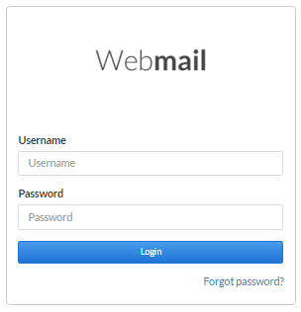
Upon first login, users are presented with an interactive Tour pop-up, highlighting the main features within Webmail.
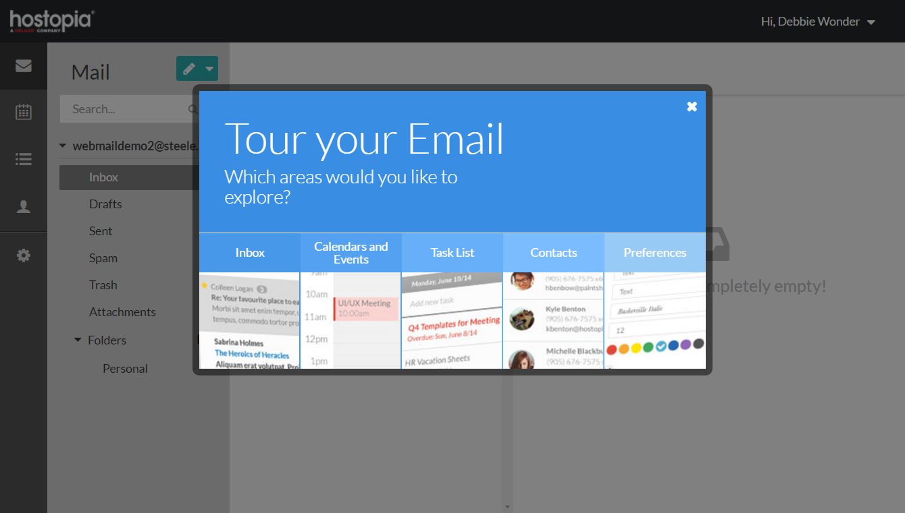

Inbox
The Inbox contains a left-hand Secondary menu that allows you to create new messages, move between or create new folders, or search folder contents.
Create folders to manage your email, and add your other email accounts to be able to view your email in one easy interface.
Webmail allows you to compose a new email, or reply or forward an existing email. You can also send email messages from your Contacts list to an individual contact or group of contacts.
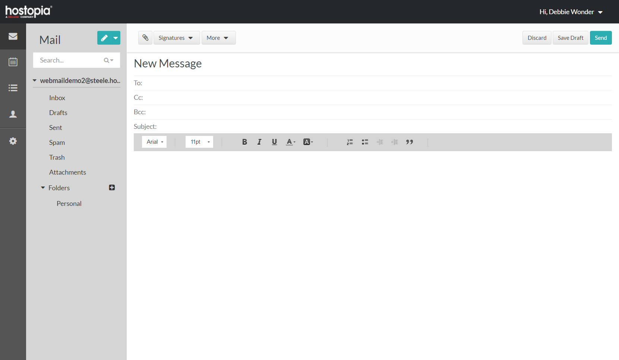
For Enhanced or Premium users, a useful “Attachments” view allows you to quickly view and download attachments received to your email, and sort by Date Received, File Name, Subject, File Size or Sender.
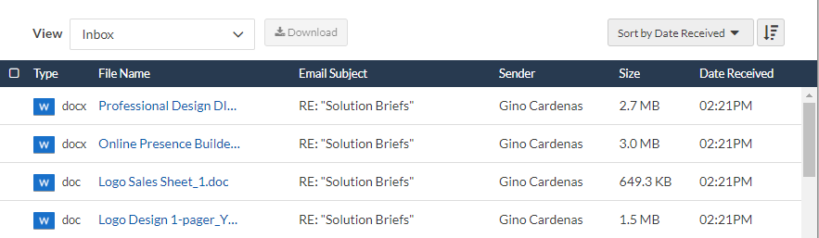

Enhanced and Premium users can also add external mailboxes to manage via their Webmail Inbox with Multi-Inbox support. Users will be able to toggle between email accounts and view all emails through one login.
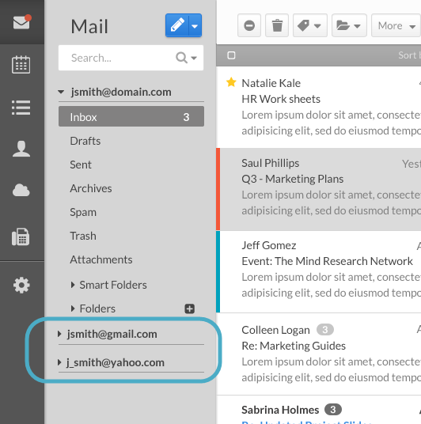

Calendar
The Calendar section allows you to schedule meetings, appointments and other events. Webmail supports multiple calendars, which display on the same daily, monthly or weekly view, allowing you to further organize and color-code various types of events.
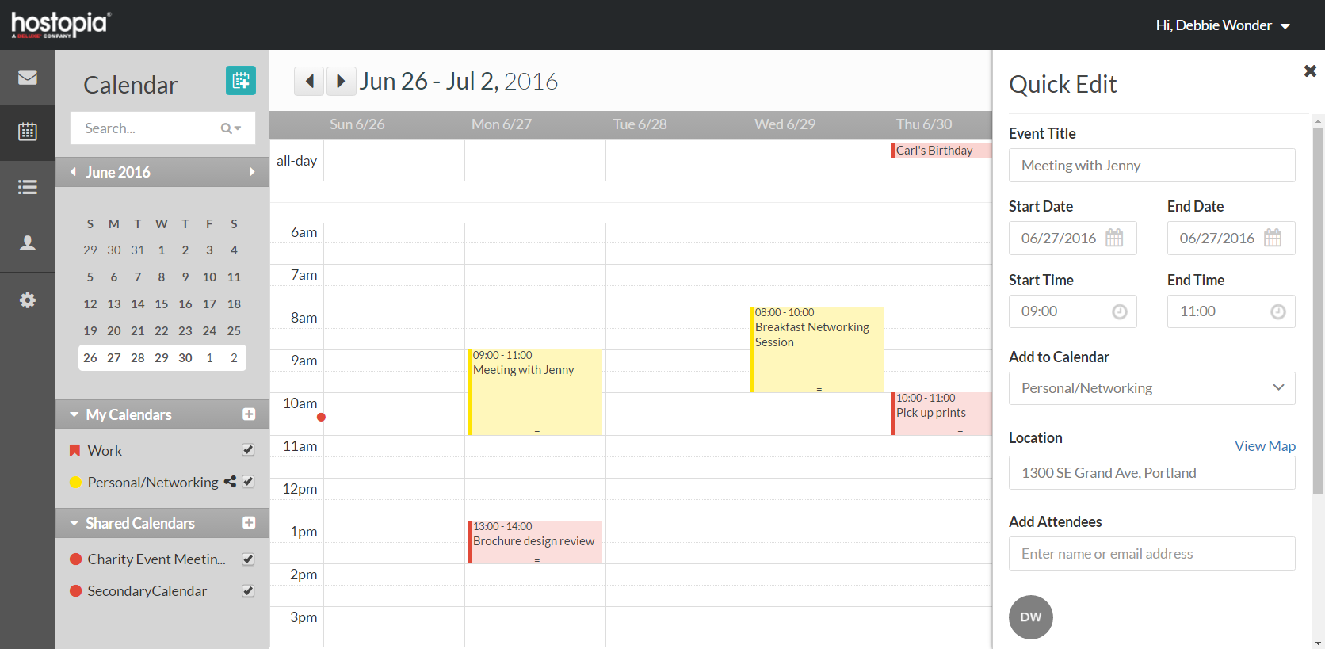
For Enhanced and Premium email, a free/busy scheduling views allows you to easily book meetings with other users on your email domain.
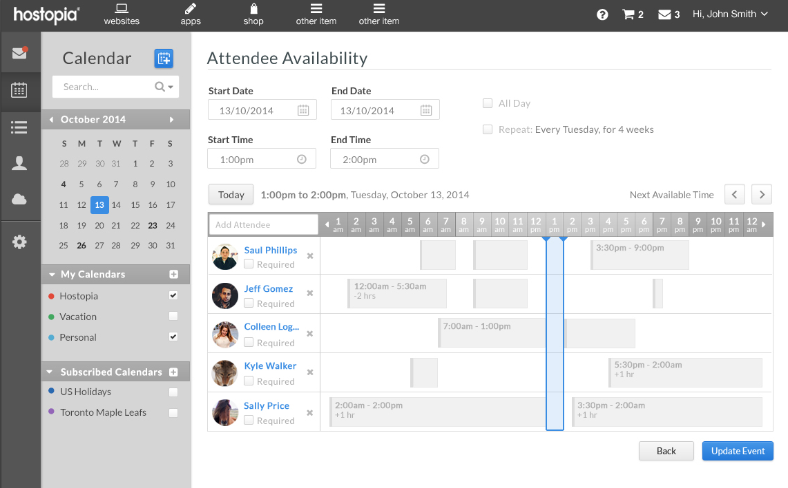

TaskBox
Webmail provides a Task list to help you prioritize tasks, set calendar events and quickly turn emails into tasks. You can also tag your tasks to help you sort and search for relevant tasks.
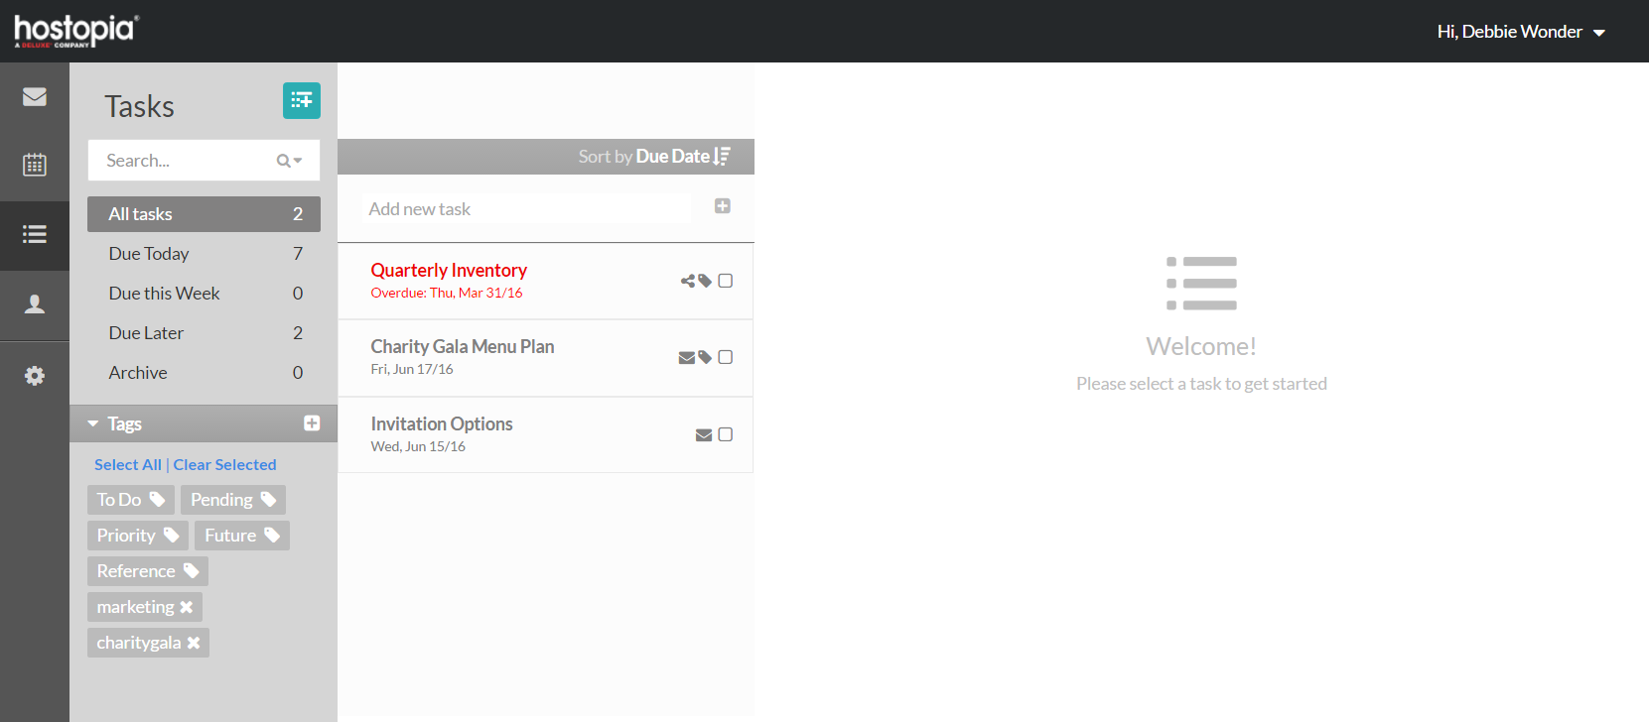
Create tasks, due dates, reminder alerts, subtasks, tags for easy sorting, notify collaborators and more.
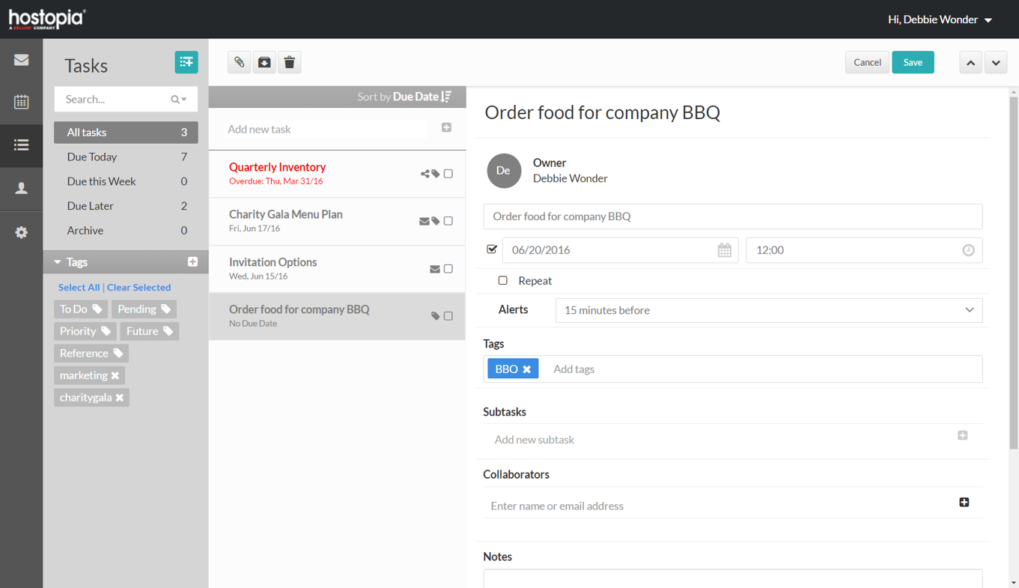
You can also turn emails into tasks using the Task sorting dropdown from your Inbox. Once your email is in TaskBox, you can add more details including reminders and tags. Enhanced or Premium users can also add collaborators to tasks, who will be notified via email.
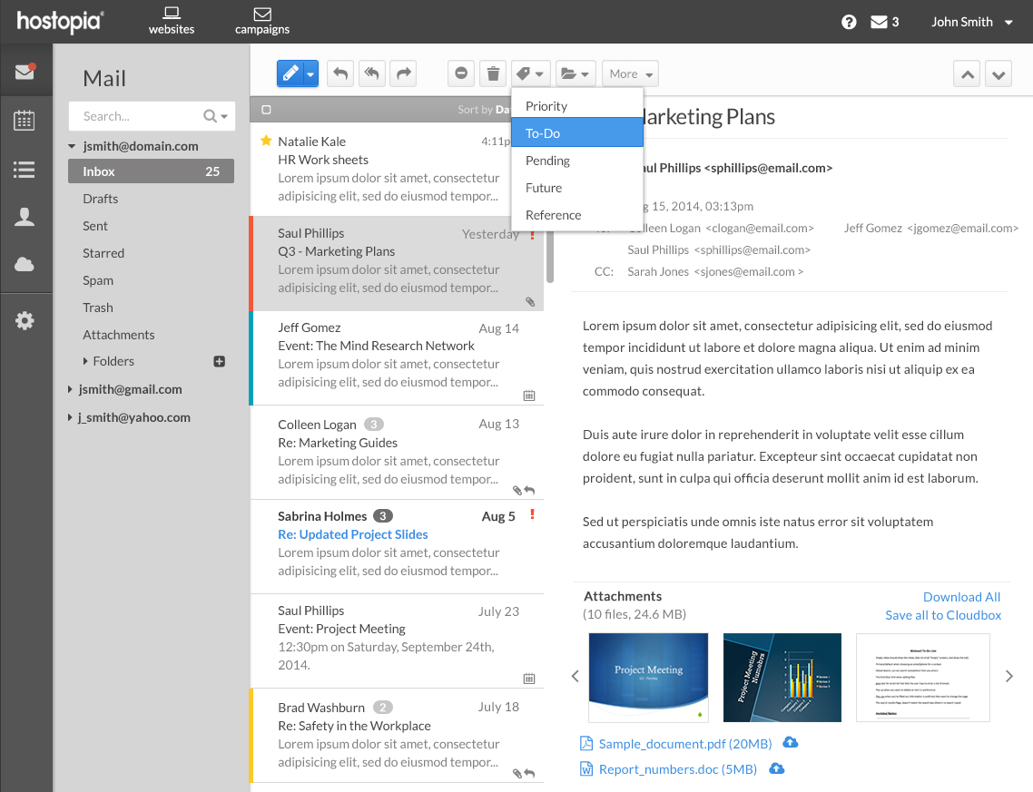

Contacts
The Contacts section allows you to manage your contacts through Groups, Address Books and Subscribed Books. This section explains the different views and lists that are available, as well as how to manage and edit contact details, groups and address books. Contacts can also be shared across the domain or with specific email address through shared address books.
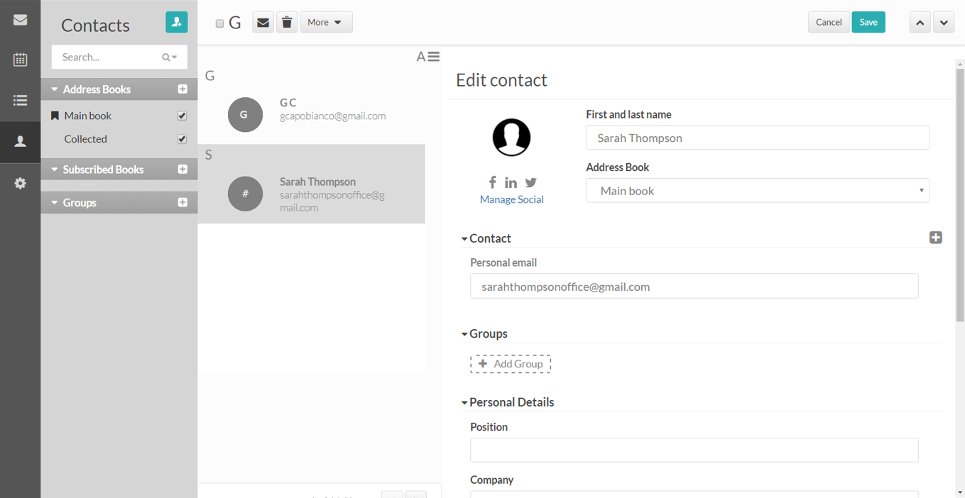

Online Storage (Premium Webmail Feature)
Premium users of Webmail can access Online Storage that allows users to upload large email and desktop attachments such as files, photos, videos and other documents.
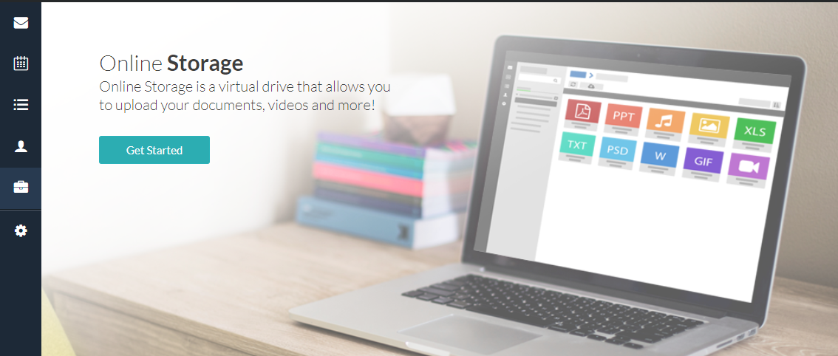
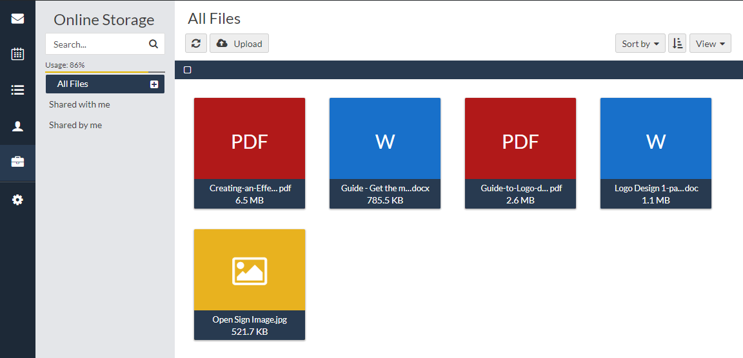
Preferences
The Webmail Preferences section allows you to manage your email account preferences, including default compose options, auto reply messages, default email signatures and more.
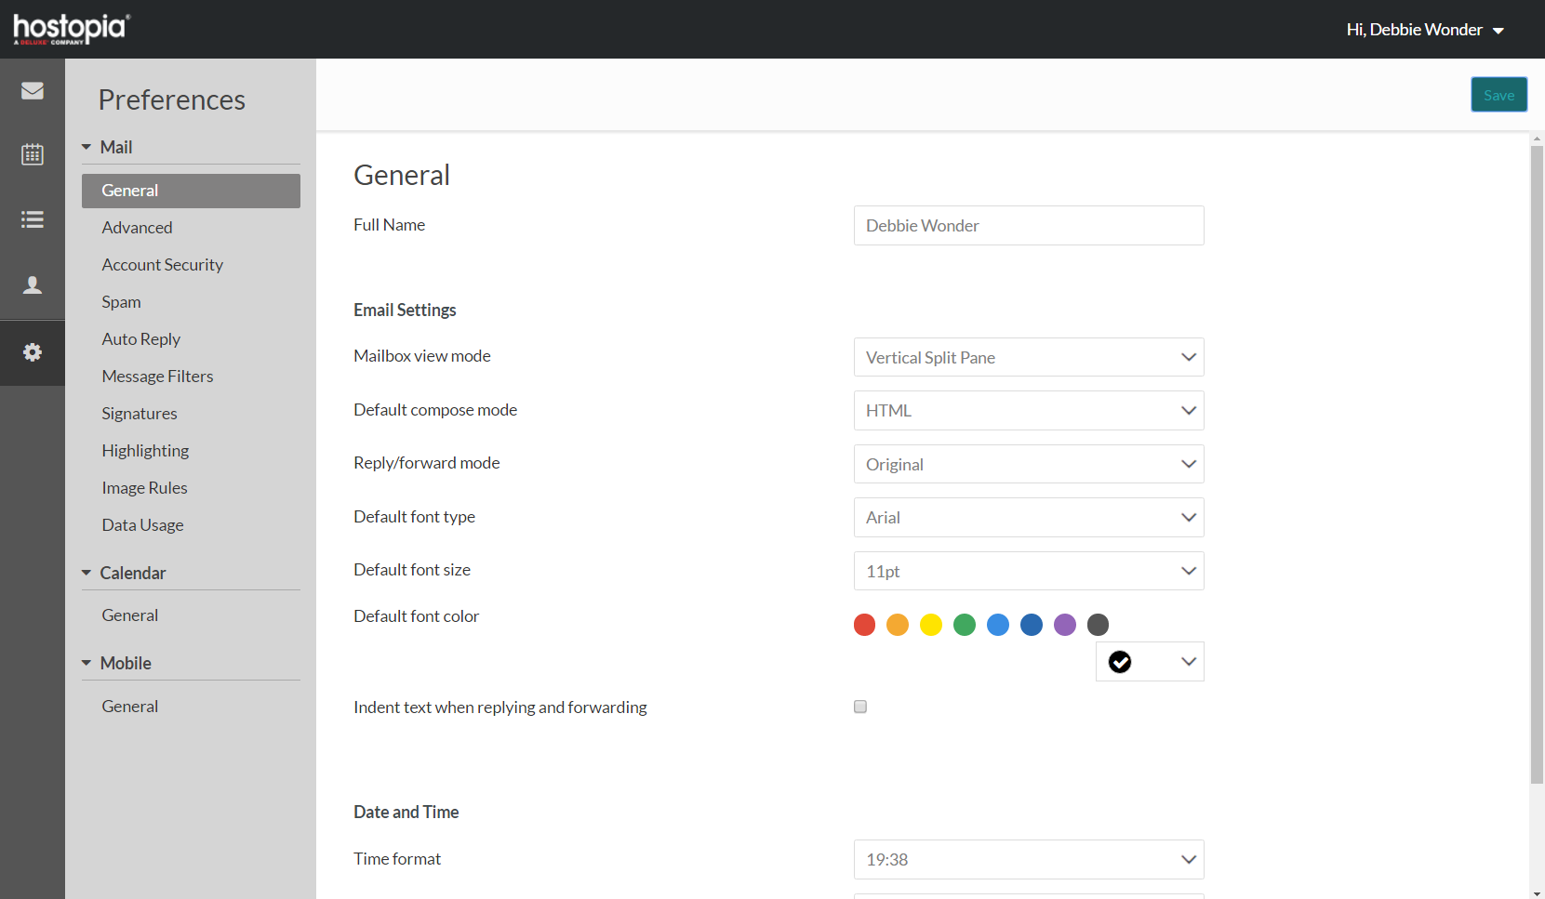

Sales Support

Probing Questions
Are you using domain-based email or free email?
or
I notice you’re using a free email service.

Branded email is important for building trust and credibility in your company—and is a really easy thing to set up!

Three-quarters (or 75 percent) of U.S ecommerce customers think having a domain-based email that matches your website is a very important factor when it comes to trusting an online small business (source).

You can have branded email set up today; all of our email packages are business class - providing top grade security and reliability with powerful productivity features, accessible via a simple to use Webmail interface.

Which email address looks better sales@mydomain.com or businessname@gmail.com? Of course the custom email looks best!

Do you have an email provider?

- Yes.
  - Is your current email solution geared for personal use? Our email solution is designed to address the needs of business users focusing on the tools that can help improve user productivity. These features include: tasks and advanced calendar features. All of your services together and we can set you up today with everything you need in one place.
- No.
  - Great, we can set you up with our business email product, which comes with an easy-to-use Webmail interface to access and manage your emails from anywhere.

Are you using Office365 or Google Mail for Business?

These are great email and collaboration tools however they also come at a premium in terms of cost. Office365 and Google Mail are first and foremost collaboration software in the cloud intended for mid to larger businesses with many employees and many locations. Because of all of these collaboration features, these products cost more per user and often provide more features than anyone really uses.

Our email solution delivers the right mix of features that users often use at an affordable and cost effective price point.

What features are important to you for an email service?

- Security – Our email offers premium levels of security and reliability; with advanced anti-virus and antispam protection and enterprise level redundancy.
- Privacy/Ad-free – Our Webmail is ad-free, so you and any team members aren’t giving your email content to your service providers to hit you with targeted ads. We protect the privacy of our customers.
- Calendar – The Webmail calendar lets you easily schedule meetings or events, view others calendars to see when they are available or just the use Smart Time Finder.*

Selling Points
Look professional and reinforce your brand.
Having your own domain-based email reinforces your brand within your everyday communication and makes it easier for customers to remember your address. It also validates you and your business.

Webmail is included and automatically available.
Webmail is our innovative online email service that gives you the ability to access, send, receive, and review email in any web browser, plus a built-in feature-rich calendar and task management.

Avoid the hassle and redundant features in Office 365 or Google.
Small businesses often need IT support to be able to set up and manage Office 365 and Google. Webmail includes productivity tools and Online Storage to stay organized and take advantage of the most useful online tools for small business, but is much easier to set-up and navigate. Simply create email accounts and you’ll get access to Webmail.

Security and reliability
With automatic virus scanning, configurable spam filtering options and optional SSL security, your email has never been safer. Our clustered server environment is both fully redundant and monitored 24X365 so you can have peace of mind knowing that your email is safe and secure.

Save money
The true costs of running email in a company are higher than you may think once you add up the cost of servers, software, and technical staff to maintain it. Our professional email system makes email management so easy, any non-technical administrator can do it. You’ll get big company performance at small company prices.

Why should I choose your business email offering?
- It’s very affordable, and email is included in our website packages so all of your services are together.
- Our domain-based email packages come with free Webmail access, a full-featured online email to manage your email, send and receive messages, and use a calendar, task management, and more. We also have packages with Online Storage for anytime access to files.* It’s a great tool to manage your email and other parts of your business in one place!
- You can add external email accounts to your Webmail Inbox so you can see all of your emails in one place.
- Our Webmail service was built for businesses like yours—premium email services are difficult to set up and offer too many complex features for most users. Webmail provides easy setup with just the right functions: email, calendar (with collaboration and free/busy scheduling included in Enhanced or Premium packages*), task management (where you can turn emails to tasks, set reminders, due dates) and Online Storage options*. Plus all these extras like multi-email inbox support. It’s really a great product!
- Organizing meetings with multiple people in different time zones can take a lot of time and effort. Webmail has a Smart Time Finder to find the perfect time to meet.* Plus you can share your calendar with anyone on your team, or publically with a personal calendar URL.*
- Our Webmail is ad-free, so you and any team members aren’t giving your email content to your service providers to hit you with targeted ads. We protect the privacy of our customers.
*Enhanced and Premium features.

Competitive Information
How does Webmail compare to other business email tools in the market?
Platform | Opportunities
Office 365  $6/user/seat & up | - Too complex to get started easily  - Paying for complex features and large-scale collaboration tools that you won’t use  - 3rd Party onboarding required  - Often requires IT support
Gmail for Business (Apps)  $5 and $10/user/seat | - Costly  - Known issues integrating with Microsoft and Apple  - Toll free support is limited  - Focused on collaboration to compete with Office365
Gmail  Free Gmail | - Google/Microsoft withdrawing from ISP mail  - Ad driven client reads your email content  - Distracts you and employees with ads
Outlook  $5/user/seat or free outlook.com | - Microsoft focused more on Office 365  - Outlook.com is Ad driven like Gmail  - Outlook is a bit outdated, doesn’t support the latest email trends

Objection Handlers
I already have an email for my business

Is your email professional, domain-based? Having domain-based email builds trust and credibility with your company, and is incredibly easy and affordable to set up.

Our email is included in website packages, so you can manage your services together!

Our email comes with Webmail, our online email to manage your Inbox—we just launched a new version with great tools to help run your business; task management, calendars that enable sharing and free/busy scheduling; and online file storage!

I don’t need all those extra features, I just need email.

Our email is secure, reliable and fully featured.

These extra are included for if you choose to use them, now or at a later date. Either way, you can rest assured that your business is protected with a carrier-grade email provider.

Why would I pay for email, when I can get it free from Gmail or Outlook?

It’s really important to your business to have secure, domain-based email versus sharing a generic Gmail, Yahoo or Hotmail account with customers or vendors.

The email providers that provide free services often have invasive ads, and are limited in what they can do. Did you know that Gmail “reads” your emails in order to serve you custom ads? Other email clients often use third party apps, so not all features are in one inbox.

I use my personal email for my business.

Having business email using your domain is really important to the credibility of your business! If you’re not ready to manage two accounts (even though you can add your personal account in Webmail to be able to see both!), you can always forward your domain-based email to a different account. Studies have shown that consumers will choose companies with professional emails over those using a Gmail or Yahoo or other email account.

Frequently Asked Questions

General
How do I create email accounts?
When you sign up, you’ll receive a Welcome email with instructions to access MailManager or EasyMail Setup. There is a really easy onboarding tool that lets you create email accounts in two steps; just type in the email and password, choose any forwarding if desired, and set spam filtering preferences.

How do I forward emails to a different email account?
There are two options for forwarding emails: creating a new email account and forward mail to a different account, or create an alias email account.
Alias accounts do not have their own Inbox and are only used to forward email to one or more accounts.
To forward email from a regular email account, create a new or modify an existing email account within MailManager or EasyMail Setup, and input the account where you would like email forwarded to under “Forward mail to:.”
To create a new alias email account, log into MailManager or EasyMail Setup and select “Create a new account” and “Create an Alias Account” and fill out the appropriate fields.

What is an alias email account and how can I create one?
An alias account is an email address which forwards to one or more email accounts. Alias accounts do not have their own inbox.
To create an alias account, log into MailManager or EasyMail Setup using the information in your Welcome email. Select “Create a new account” and “Create an Alias Account” and fill out the appropriate fields.

How can I access Webmail?
Once you create an email account, you will be able to login to Webmail to use your email. The Webmail link will be included in your Welcome message.
From Webmail you’ll be able to start sending and receiving emails.

How can I change my password?
To change your main email account password, log in your account through Portal, open the email application, select “Modify an existing Email Account” and select “change password.”
To change your Webmail password, select “Preferences” (gear icon) from the left-hand menu within Webmail. Select “Account Security”, and input your current and new password. Hit “Save.”

How do I add my email to an iOS device?
- On your device, go to Settings > Passwords & Accounts.
- Tap Add account.
- Tap Other.
- Next, select Add mail account.
- Enter your name, email address, email password and a nickname (description) for your account.
If mail does not find your email settings and automatically set up your account, follow these steps:
- In your Webmail account go to Preferences > POP/IMAP. Keep the tab open as you will need to enter this information into your mobile device.
- Enter the information for Incoming Mail Server (POP) and Outgoing Mail Server (IMAP) on your mobile device. You may also need type your email username (i.e. john.carrington) and password again. (You do not need to add your full email address in the "User Name" field)
- Select, Next.
- Last, if your email settings are correct select Save to complete setup, if they are not you may need to re-enter your information.
Note: Make sure your email your username and password are typed in correctly.
If you are still having issues connecting your email account, try getting in touch with the technical support team for your iOS device.
How do I add my email to my Android device?
- Open the Menu, then select System settings.
- Select Accounts > Add account.
- Enter your email address and email password.
- Select IMAP (recommended), or POP.
- Enter your email address and email password.
- Enter the server mail.yourdomain.tld (ex: mail.examplesetup.ca) followed by the port number. (This can be found in your Webmail under Preferences > POP/IMAP)
Note: be sure that the Security Type is None.
- Enter Inbox in the IMAP Path Prefix. C
- Click, next.
For the SMTP Outgoing mail server:

- Input mail.yourdomain.tld (ex: mail.examplesetup.ca) followed by the port number. (This can be found in your Webmail under Preferences > POP/IMAP)
Note: be sure that the Security Type is None then check the box for Require Sign-In.
- Enter your email address next to the username followed by the password for your email address.
- Click, next.
Note: Make sure you have entered your username and password correctly.
If you are still having issues connecting your email account, try getting in touch with the technical support team for your specific Android device.

What is TaskBox?
TaskBox helps you manage your Inbox to-do list. It will help you instantly organize your inbox into categories that make sense all within the inbox such as: priority, future, pending and future reference. You’ll be able to set reminders, dues dates and even share/assign tasks to other people!
To activate the function to tag emails to turn them into tasks, select “Preferences” (gear icon) from the left-hand menu within Webmail. Select “Advanced”, and make sure the checkbox next to “Turn on TaskBox” is checked. Click “Save.”

What is Online Storage?
Online Storage is an online file-sharing tool that allows you to access your files from anywhere. Share files via secure URL or email them directly, making it easy to work from anywhere!

How can I change set an Auto Reply message to respond to incoming messages while I’m absent?
To set up an Auto Reply, select “Preferences” (gear icon) from the left-hand menu within Webmail. Select “Auto Reply”, and input a title, start and end date, any conditions and the content of your message and hit “Save.”

How can I create a default email signature on my outgoing emails?
To create an email signature, select “Preferences” (gear icon) from the left-hand menu within Webmail. Select “Signatures”, and input a title, and write and format your email signature and click “Add.” Your new signature will now appear on your List of Signatures.
You can create multiple email signatures and select a default signature by selecting the star next to the title on your List of Signatures. When composing a new email, your default email signature will appear at the bottom of the email and there will be a dropdown of all of your available signatures so you can select an alternative signature if desired.

Where can I see my data usage or disk space used?
In Webmail, select “Preferences” (gear icon) from the left-hand menu within Webmail. Select “Data Usage” to view your disk space used and remaining, as well as a breakdown by Inbox folder.

Full Feature List: Webmail
Features
Email Storage Per Email Box | Multiple options available
# of mailboxes included | Multiple options available
Configurable Anti-Virus and Spam Filtering | ✓
Autoresponder | ✓
Autoresponder Time Period Settings | ✓
Max Attachment Size | 25 MB
EasyMail Setup or MailManager app to create and manage email accounts | ✓
Blacklisting / Whitelisting | ✓
IMAP, POP3, SMTP | ✓
Unlimited Catch-all | ✓
Mobile Access - iPhone, Android | Native apps
Webmail
Send from different addresses in same webmail client (Alias creation and sending) | ✓
Text / HTML message creation | ✓
Priority Settings and Read Receipts | ✓
Auto fill of email addresses into To, Cc, Bcc from contact list | ✓
Drag and drop attachments from desktop | ✓
Drag and drop/ add attachments from Online Storage | ✓  Available Premium packages
Auto save message compose | ✓
Multi Mailbox Support (integrate IMAP mailboxes including Gmail, Yahoo and Hotmail accounts with accordion viewing) | ✓  Available in Enhanced and Premium packages
Set Webmail compose default font style, size and color adjustment | ✓
Spell check | Browser Based
Attachment view (easily view and download received attachments in Attachment view; filter by mail folder) | ✓  Available in Enhanced and Premium packages
Attachment thumbnail preview with carousel | ✓
Threaded messages view (Conversation view) | ✓
View horizontal or vertical messages | ✓
Quick "add event to calendar" from message body (Natural Language Parsing) | ✓
Click to view address location found in the body of an email (Google Map view) | ✓
Contacts
Create new contacts and groups | ✓
Import/Export Contacts | CSV, Yahoo! Mail, Gmail, Hotmail
Share and subscribe to Address Books with Team Members | ✓
Sync Contacts to Mobile | SyncSuite (CardDav)
Photo Upload to contact | ✓
Distribution Lists | ✓
Collected Address Book | ✓
Calendar
Supported calendar types | iCal, WebDav (CalDav)
Create new calendars | ✓
Share and subscribe to Calendars with team members | ✓  Available in Enhanced and Premium packages
Upload iCal and/or Calendar URL from external source and view | ✓
Schedule new events - add attendees; set meeting location; set recurrence schedules | ✓
Scheduler adjusts attendees based on their Time Zones | ✓
Scheduling Assistant (Suggest the next free time to meet across attendees on the domain) | ✓
View Free/Busy times | ✓  Available in Enhanced and Premium packages
Set Reminders X minutes before event on specific days or intervals | ✓
Share calendars outside of your domain (Personal Calendar URL with Free/Busy Times) | ✓  Available in Enhanced and Premium packages
Delegate access (View, Manage, Admin) of Shared Calendar | ✓
Multiple views - day; week; month, agenda, | ✓
Drag and drop events - change dates, expand meeting times | ✓
Create and track tasks | ✓
Create Notes | ✓
Tasks
TaskBox management | ✓
Create, edit tasks | ✓
Add due dates and reminders | ✓
Sorting of tasks (Due Today, This Week, Later, Shared, No Due Date, Create Date, Inbox Zero tags) | ✓
Tagging of tasks | ✓
Click tag to sort on ANY or ALL tags | ✓
Sub tasks creation with a Task | ✓
Add task collaborators | ✓  Available in Enhanced and Premium packages
Share tasks | ✓
Task notes | ✓
Add attachments | ✓
Online Storage / File Management | Available in Premium packages
Storage Size | Multiple options available
Save attachments to storage | ✓
Share saved documents from storage | ✓
Folders
Create and Rename Folders | ✓
Sub folder creation | ✓
Search | ✓
Basic Search - In New Window | ✓
In Folders; From; To; Subject, Spam, Shared Tasks, Calendars | ✓
Advanced Search - Within Webmail Client - Message Body, In Folder | ✓
Utilities
Webmail Options | ✓
Keyboard shortcuts | ✓
Reading Pane (Bottom, Side, Off) | ✓
Set name that appears when an email is sent | ✓
Sort by - Received; Subject; Of; Date | ✓
Frequency of Updating Inbox - disabled; 5mins; 10mins; 20mins; 30mins; 1 hour | Auto Refresh
Number of Emails Displayed - 10; 25; 50; 100; 200 | ✓
Time Zone Set | ✓
Encoding Standard Message | ✓
Block images in email - show for all; show users in contact list; block all | ✓- option directly in email message
Editor HTML Email | ✓
Time Format - 12 hours; 24 hours | ✓
Date format - DD/MM/YY; MM/DD/YY; YY/MM/DD | ✓
Create and apply default signatures (HTML or Text) | Multiple
Forward messages to another email address | ✓
Play sound when new email arrives | ✓
System Windows for screen readable programs | ✓
Reply/Forward mode setting - original, HTML, text | ✓
Change Password | ✓
Message and Image Rules | ✓

<< DOCUMENT END >>

